Space Parallax Instructable

Steps to load and play the game:

1. Make sure your HTC Vive headset and controllers are plugged in and you can be tracked by the base stations.

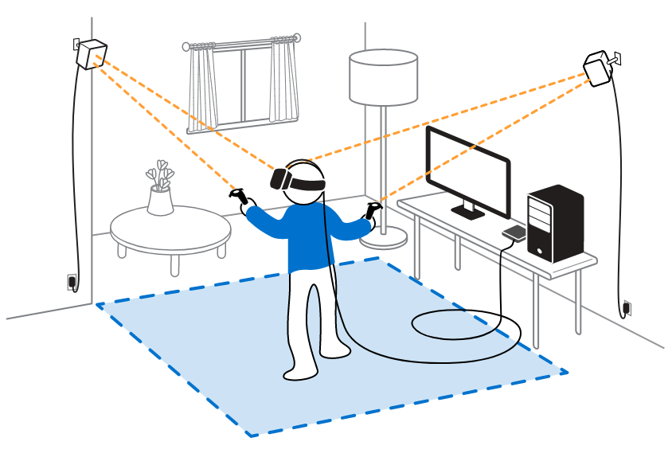

1. Click on the SpaceParallax.exe file.



1. You should be brought to the Main Menu of the game. To start, press Play!

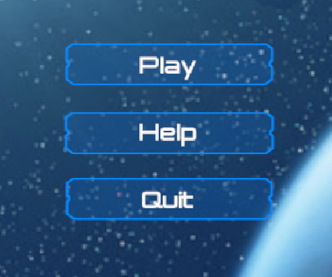

1. You should now be able to see the different levels we have created. Click on any level with your mouse and put on your Vive headset and grab the controllers. This is much easier to do with another person helping you press play and holding controllers for you. 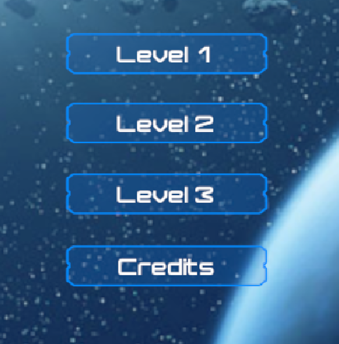
2. You should be in the game now. Hold up both of your hands (controllers) to make sure they are visible. There should be an HTC Vive controller model in your left hand and a gun in your right hand.

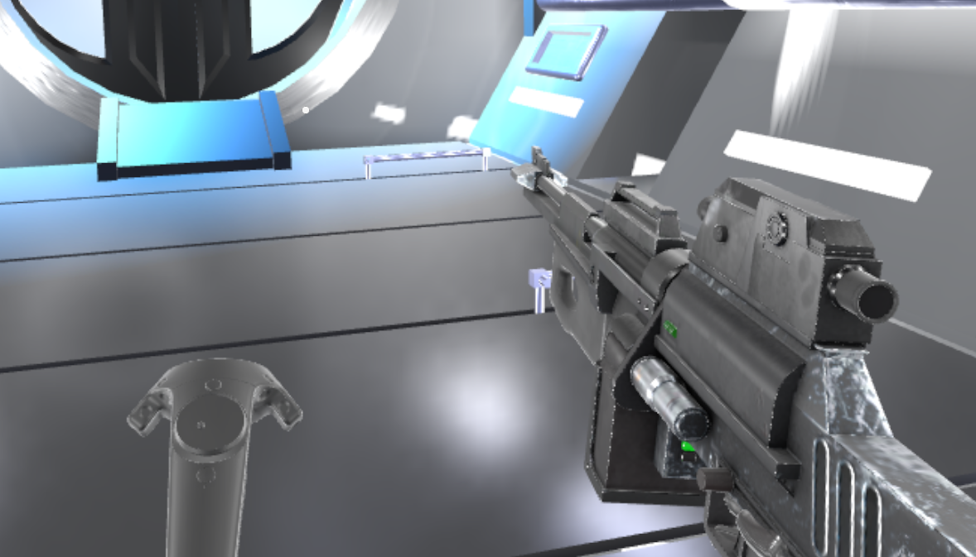

1. First, you need to learn how to move. Using your left hand, press the “up” button on the HTC Vive’s trackpad. To move in different directions, you will need to aim the controller to whatever direction you want to move. Think of your arm as an arrow to guide you in the direction you are trying to move.

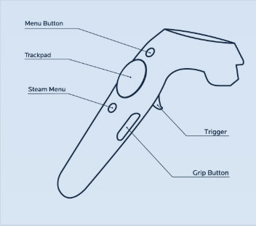

1. Next, let’s learn how to aim and shoot the gun. Hold up your right hand and use your fingers to grab the grip button on the controller(change to pull the trigger later if we get the new exe file working). To aim at a target use your right hand to point the gun in any direction you want. The gun will always shoot at whatever direction your arm is pointing towards.

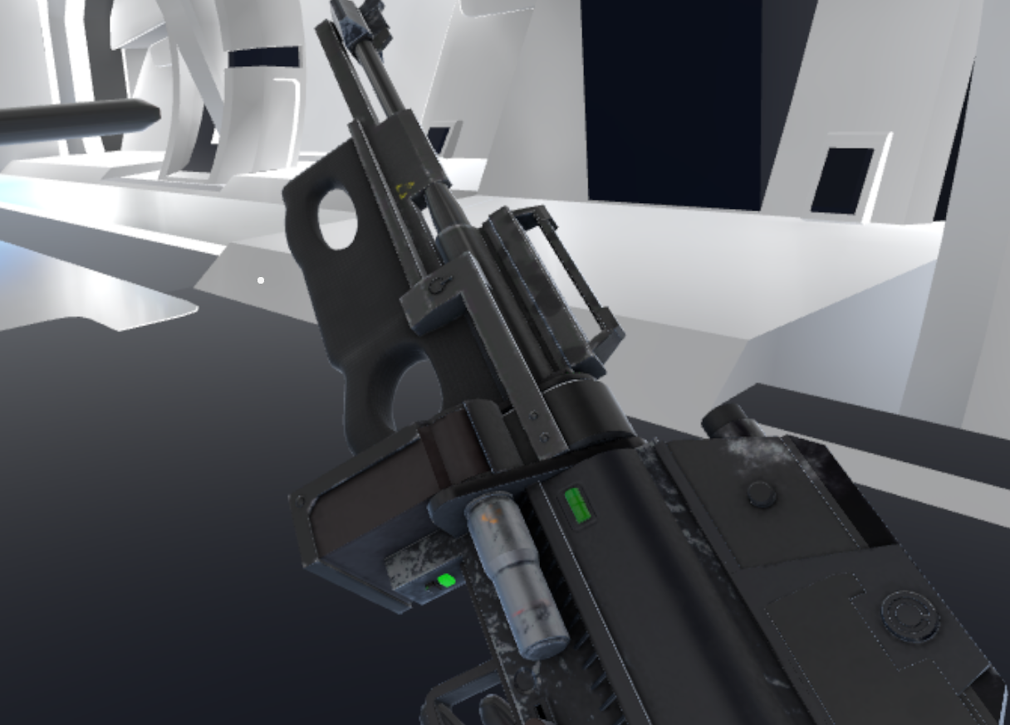

1. There will be destroyable objects and robot enemies throughout the levels. Move throughout the levels and destroy any robots you can find.

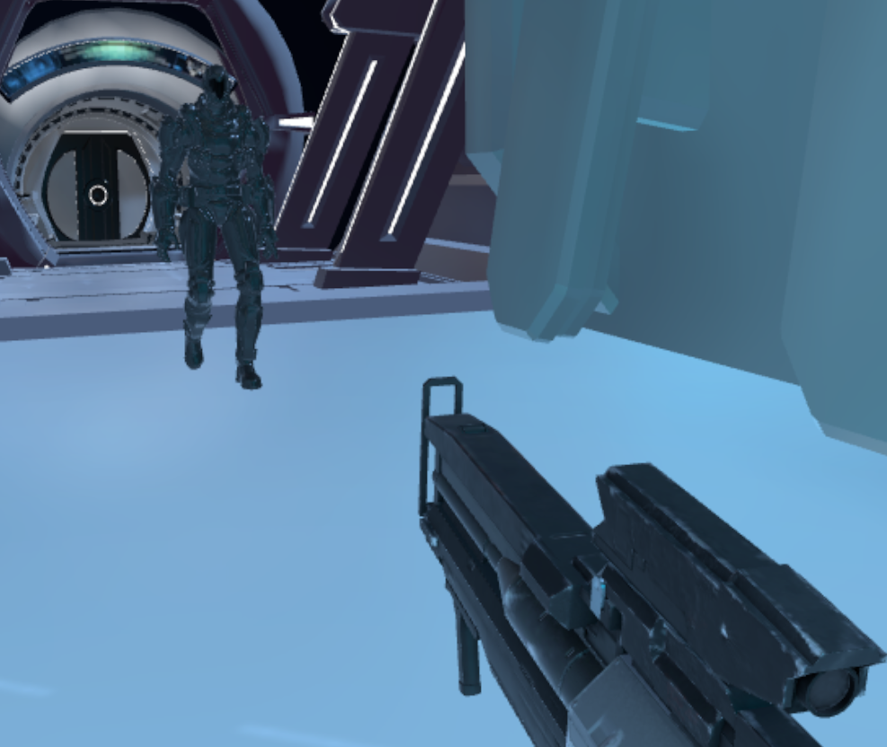

1. We do not have an Exit button or a way to pull up the menu, so to exit the game and start a new level you will have to close the Space Parallax application and reopen it.
2. Keep in mind that this is not the longest gameplay experience, so enjoy the environment and explore all of the corners of each map. This took a long time to build and many people going too fast will not see all of the content each map has to offer.

